English  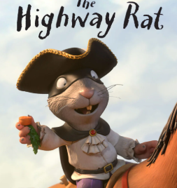  Write your own ending to The Highway Rat (Year 2: include and to join ideas; Year 1: use simple sentences with correct punctuation). | History  Create a presentation, poster or booklet comparing the past and present in your life.  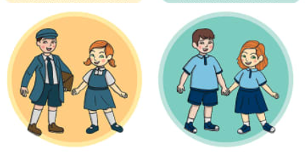 | PE  Invent your own superhero vegetable and write a fact file describing its what it looks like, powers and adventures.  Year 1/2 Take Away Homework!  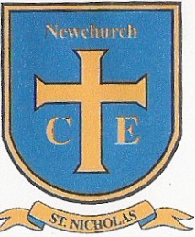  Choose your homework from the menu below:  The Peri-ometer suggests the difficulty or challenge the  homework may offer. Each week you must choose your task from the menu ensuring that at least one ‘EXTRA HOT’ task is completed over the half term!  Each of the homework tasks are worth the following rocket points:  Extra Hot 15  Hot 10  Mild 5  Extra Mild 2  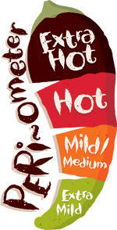  These homework tasks are in addition to home reading tasks and Numbots & TTRS.  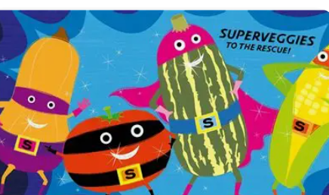
History  Interview a family member by asking them questions about their childhood and compare it to yours e.g what school did you go to?  What, When, Where How? | RE  Create a poster explaining why Christians say God is Father. | PE  Design and complete your own Supertato movement challenge (jumping, balancing, throwing and catching).
English  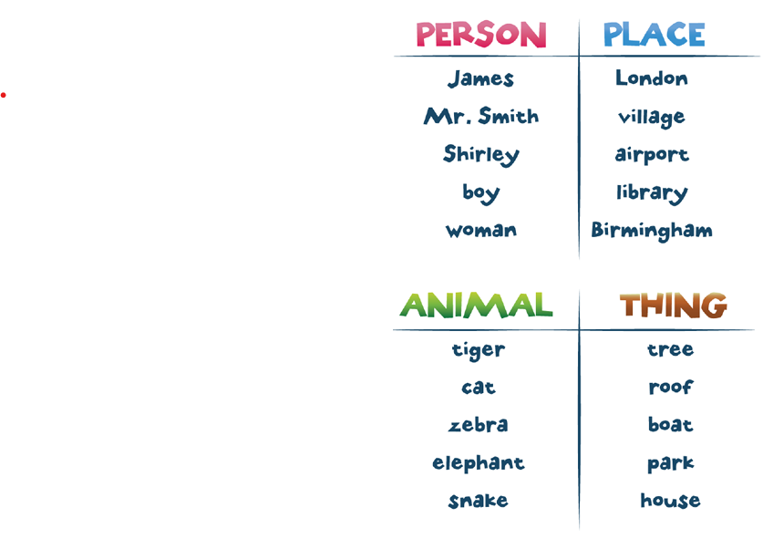  Make a list of 10 nouns you can find around your house. | Maths  Create a shape picture using at least 4 different 2D shapes.  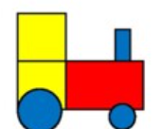 | Science  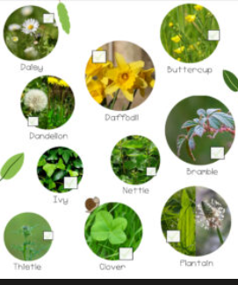  Go on a plant hunt and draw or label 5 different plants.
History  Draw a picture of your favourite memory and tell someone about it.  This could be starting school, visiting the beach or a birthday. | Maths  Find and name 5 different shapes around your home. 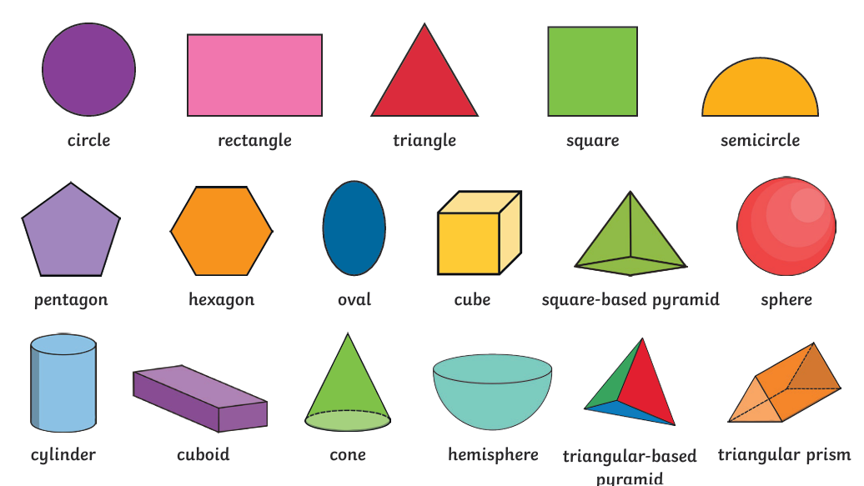 | Computing  Sort your toys into groups and explain how you grouped them. 

