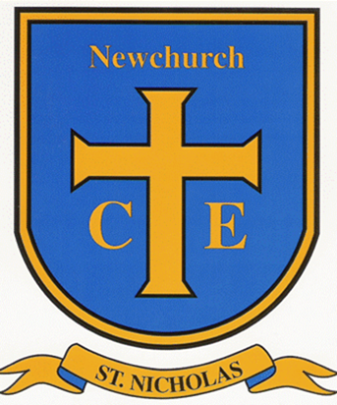
As historians we will explore the concept of the past and present by learning about their own lives and experiences. They will create a personal timeline, learn what a memory is, and begin to understand the difference between living memory, childhood, and events that happened before they were born. Through discussions and activities, children will compare life in the past with life today, helping them develop their understanding of chronology and how things change over time.

As artists children will explore drawing as a creative and expressive activity. They will learn that drawing can involve both the body and emotions, and will experiment with controlling the lines they make by varying how they hold drawing tools, the pressure they apply and the speed of their movements. Children will create drawings from both observation and imagination and discover how colour can be used to make their artwork more engaging and expressive. #

English
This half term, our English learning will be based on The Highway Rat. Year 1 children will build on their Reception writing skills, focusing on phonics, sentence writing and handwriting, while Year 2 children will develop their use of adjectives to add detail to their writing.
In grammar lessons, both year groups will learn to identify nouns, verbs and the subject of a sentence through activities linked to our class text. Year 1 children will focus on writing and punctuating simple sentences, while Year 2 children will begin using conjunctions such as and to join ideas. The unit will end with children creating their own version of The Highway Rat, applying the skills they have learned throughout the term.
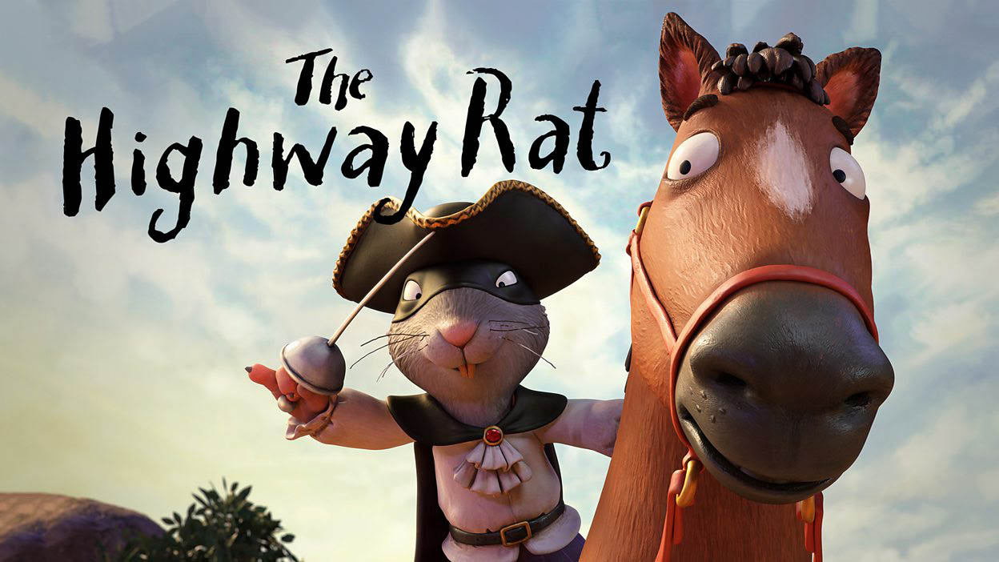

RE This half term in RE, children will be exploring the question "Why do Christians say God is Father?" They will learn about Christian beliefs about God as a loving and caring Father and explore how these beliefs influence the way Christians live their lives. Through stories, discussion and reflection, children will begin to understand the importance of God in the Christian faith and what this means to Christians today.

Maths
Place value
Addition and subtraction
Shape
This half term in Maths, children in both Year 1 and Year 2 will develop their understanding of place value, learning to recognise, represent and compare numbers. They will then build their confidence in addition and subtraction, using a range of practical resources and written methods to solve problems. Children will also explore shape, identifying and describing the properties of 2D and 3D shapes and using mathematical vocabulary to talk about their features.

Computing
This half term in Computing, children will learn about grouping data. They will explore how objects and information can be sorted and organised into groups based on their characteristics. Through practical activities, children will develop their skills in identifying similarities and differences, creating groups, and understanding why data can be organised in different ways to help us find information more easily.

As scientists, we will learn about plants and how to care for them. They will identify and name a variety of common wild and garden plants, including trees, and learn about the basic structure of plants, such as roots, stems, leaves and flowers. Children will investigate what plants need to grow and stay healthy, including water, light and suitable temperatures. Through practical activities, they will develop their observation skills and learn how to work scientifically by asking questions, making observations and recording what they find.

Autumn 1
Year 1-2 26/27
PE
This half term in PE, children will develop their fundamental movement skills through activities linked to the story Supertato. They will practise a range of skills, including running, jumping, hopping, balancing, throwing and catching. Through imaginative games and challenges, children will improve their coordination, agility and control, while also developing teamwork, confidence and an enjoyment of physical activity.

