Autumn 1
Y6 Take Away Homework

Choose your homework from the menu below:
The Peri-ometer suggests the difficulty or challenge the
homework may offer. Each week you must choose your task from the menu. You may choose to complete more than one if you wish. Homework should be returned on a Wednesday morning.
These homework tasks are in addition to TTRS and home reading tasks.
Each of the homework tasks are worth the following rocket points:
Extra Hot 15 Mild 5
Hot 10 Extra Mild 2

Art  Make a shadow puppet with a moving part. You can use any materials you have lying around at home.  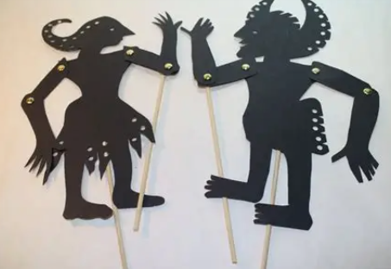 | Life Skills: Make a Simple Meal  Encourage your child to plan and make a meal for the family (with assistance if needs be). Evidence this through photos, writing the recipe, or making a comic strip of the process. | E-Safety  Create an e-safety poster about sensible use of mobile phones. It should have plenty of information, be presented well and be illustrated.
RE  In RE, we are looking at making the right choices, even when it is hard to do so and looking at this through a Christian lens. We will be examining the traditional Lord’s Prayer. Rewrite this in modern-day language and illustrate it for display. Original copies are available in class. | History  Collect a census homework from class. Look at the 2 censuses and answer the accompanying questions. Neatly and in full sentences where needed please. | PE  Create an A4 page fact file about your sporting hero. You can use one of the templates from class or make your own, but it must have a page of information. It could include their achievements, height, DOB, family, fun facts, why they are your hero, etc.
Spellings  Learn 5 words from your Y5 or Y6 spelling list. Come to me at break or dinner time and I will test you on the ones you have practised. | Grammar  Ask your teacher for a worksheet on something you have been learning this week in class to practise. | Life skills  Knowing how to locate and turn off the stop tap is an important life skill that can help prevent water damage and keep homes safe in the event of a leak or burst pipe. Find the stop tap in your home! Take a photo of yourself with it.
Reading  Ask your teacher for a 60 second task comprehension sheet to complete. | Recommended Read/ Oracy  Bring in a favourite book you have read and introduce it to the class. You must be able to say to the class why you have enjoyed it and why you would recommend it. | TTRS  We encourage all children to log into Times Tables Rock Stars each week to strengthen their mathematical fluency. As part of our homework menu, pupils may choose to count a TTRS session as one homework task once per half term.

