

Year 1 - Arithmetic Expectations
This series of documents aims to summarise the number facts, mental calculation strategies and the stage(s) of the progression towards the written methods for each of the four operations.
For each strategy, the concrete and pictorial representations have been suggested. However, to keep the document to a more manageable size, the imagery has not been shown explicitly as this should be found in your school’s agreed mental calculations policies.
The strategies used within this document are taken from the Lancashire Mathematics Team Progression in Mental Calculation Strategies Policies and the Progression Towards Written Methods Policies.
Each strategy will require specific modelling (teaching) and sufficient practice for children to develop confidence, accuracy and fluency in performing them.
Children should also be taught when it is appropriate to use each strategy, by looking at the numbers involved and making effective decisions. Again, this is a sign of a child’s fluency in mathematics; being able to recognise which strategy best suits a given calculation, rather than always using the same method regardless of the numbers involved.

Arithmetic Expectations – Year 1
Skills | Examples
Counting
Count in multiples of 2, 5 and 10. | Count from 0 in twos  What number would come next in this counting sequence? 0, 5, 10, 15, 20, __  What number is missing from this counting sequence? 0, 10, 20, 40, 50
Recognise even and odd numbers when counting in twos from 0 or 1. | Continue this count: 2, 4, 6, 8, 10, 12, 14…  Are these even numbers or odd? How do you know?  Continue this count: 1, 3, 5, 7, 9, 11, 13…  Are these even numbers or odd? How do you know?  Which are the even numbers in this set? 5 16 22 47 32
Number Facts
Recall number bonds and related subtraction facts for all numbers to 10. | 6 + 4 = __ 2 + __ = 10 10 = __ + 5 10 – 3 = __ 10 – __ = 1 7 = 10 – __  3 + 4 = __ 5 + __ = 7 7 = __ + 6 7 – 2 = __ 7 – __ = 3 5 = 7 – __
Recall doubles of all numbers to 10 and corresponding halves. | 3 + 3 = __ double 6 is ___ half of 14 is ___ halve 8 double ___ is 10
Partition numbers into tens and ones. | 46 is 40 and 6
Mental Calculation Strategies – Addition and Subtraction
Count on or back in ones (chain count and link to objects, i.e. 1-1 correspondence).  Concrete – counters, beadstring, cubes on a number track  Pictorial – number line | 4 + 5 count on in ones from 4 (or in ones from 5)  8 – 3 count back in ones from 8  10 + 7 count on in ones from 10 (or use place value)  13 + 5 count on in ones from 13  17 – 3 count back in ones from 17
Reorder numbers in a calculation.  Concrete – counters, counters in a ten frame | 8 + 3 doesn’t need reordering as the greater number is first already  2 + 7 reorder as 7 + 2  5 + 13 reorder as 13 + 5  11 + 6 doesn’t need reordering as the greater number is first already
Partition small numbers, e.g. 8 + 3 = 8 + 2 + 1 and 11 – 3 = 11 – 1 – 2  Concrete – counters in a ten frame, beadstring  Pictorial – number line | 7 + 5 partitioned as 7 + 3 + 2  9 + 7 partitioned as 9 + 1 + 6  6 + 8 partitioned as 6 + 4 + 4 or reordered and partitioned as 8 + 2 + 4  12 – 5 partitioned as 12 – 2 – 3  14 – 8 partitioned as 14 – 4 – 4
Mental Calculation Strategies – Multiplication and Division
Apply counting in twos, fives and tens to solve multiplication problems with a repeated addition context.  Concrete – real items to model the context of the problem  Pictorial – images of the items in the context of the problem | How much money is the total of six 5p coins?  How many fingers would seven children have altogether?  How many boots are lined up after five children take them off?
Share an amount into equal parts.  Concrete – real items to model the context of the problem  Pictorial – images of the items in the context of the problem | A bunch of 20 grapes are shared equally between two children? How many grapes do they each get?  Five children are given £50 to share equally by their grandma. How much money do they each get?

Separate an amount into equal groups.  Concrete – real items to model the context of the problem  Pictorial – images of the items in the context of the problem | Each sandwich needs two slices of bread. How many sandwiches can be made using 20 slices of bread?  Five seeds need to be planted in each pot. How many pots can be planted if there are 30 seeds altogether?
Progression Towards Written Calculation Strategies – Addition
Count on to find the total.  Concrete – ten frames, Diennes equipment  Pictorial – images of ten frames, tens and ones jottings | 11 + 5  Add the ones, then add the ten(s)
Progression Towards Written Calculation Strategies – Subtraction
Count the amount to subtract (take away) and count the amount left.  Concrete – ten frames, Diennes equipment  Pictorial – images of ten frames, tens and ones jottings | 13 – 4 To avoid the need to exchange, it is advisable to use cubes or counters.  Count the amount (part) to subtract (take way)  1  2  3  4  1  2  3  4  5  6  7  8  9  Count the amount (part) that is left.
Progression Towards Written Calculation Strategies – Multiplication
Recognise multiplication as real arrays showing repeated addition.  Concrete – real arrays e.g. baking trays, ice cube trays, egg boxes  Pictorial – images of real arrays | 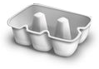  How many eggs are needed to fill the box?  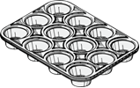  How many buns can be made with this tray?
Progression Towards Written Calculation Strategies – Division
Recognise division as sharing amounts into equal parts. Introduce simple remainders as the items are shared into equal parts, but some may be left over.  Concrete – real sets of items shared according to a real context  Pictorial – images real items being shared into equal parts (possibly represented as shapes) | 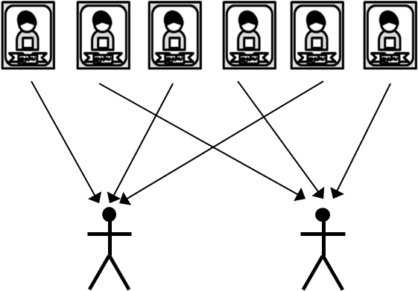  Six stickers shared equally between two children.  How many stickers will they each get?  If it was seven stickers being shared equally between  two children, how many stickers would they each get?
Decision Making
When calculating, children should ask themselves:
- do I know the answer because it is a fact I have learnt?
- can I work it out easily in my head?
- can I use some equipment or a jotting?
The strategies used within this document are taken from the Lancashire Mathematics Team Progression in Mental Calculation Strategies Policies and the Progression Towards Written Methods Policies.
See www.lancsngfl.ac.uk/curriculum/primarymaths for the full policies.

