

Year 2 - Arithmetic Expectations
This series of documents aims to summarise the number facts, mental calculation strategies and the stage(s) of the progression towards the written methods for each of the four operations.
For each strategy, the concrete and pictorial representations have been suggested. However, to keep the document to a more manageable size, the imagery has not been shown explicitly as this should be found in your school’s agreed mental calculations policies.
The strategies used within this document are taken from the Lancashire Mathematics Team Progression in Mental Calculation Strategies Policies and the Progression Towards Written Methods Policies.
See the school website for the full policies.

Each strategy will require specific modelling (teaching) and sufficient practice for children to develop confidence, accuracy and fluency in performing them.
Children should also be taught when it is appropriate to use each strategy, by looking at the numbers involved and making effective decisions. Again, this is a sign of a child’s fluency in mathematics; being able to recognise which strategy best suits a given calculation, rather than always using the same method regardless of the numbers involved.

Arithmetic Expectations – Year 2
Skills | Examples
Counting
Count in multiples of 2, 3 and 5 from 0.  (Counting in 2s and 5s from 0 is continuation of Year 1 expectations). | Count from 0 in: twos; fives; threes.  Complete these counting sequences:  0, 5, 10, 15, 20, __, __, __ 0, 2, 4, 6, 8, __, __, __ 0, 3, 6, 9, __, __, __  What number is missing from this counting sequence? 0, 3, 6, 9, 12, 15, 18, 24, 27
Count forwards or backwards in steps of 1 or 10 from any one- or two-digit number | Count forwards in ones from 75 to 92  Count back in ones from 54 to 38  Continue these sequences:  24, 34, 44, __, __, __ 89, 79, 69, __, __, __ 44, 34, 24, __, __
Count on and back in steps of $\frac{1}{2}$ and $\frac{1}{4}$ | Count from 0 in steps of $\frac{1}{2}$  When counting from 0 in steps of $\frac{1}{4}$ what comes immediately after $\frac{3}{4}$?  Answer could be $\frac{4}{4}$ or 1  Count back in steps of $\frac{1}{2}$ from $\frac{6}{2}$ Count back in steps of $\frac{1}{2}$ from 2$\frac{1}{2}$
Number Facts
Recall number bonds and related subtraction facts for all numbers to 20 | 16 + 4 =__ 2 +__= 20 20 =__+ 5 20 – 13 =__ 20 –__= 1 6 = 20 –__  3 + 14 =__ 5 +__= 14 14 =__+ 6 14 – 2 =__ 14 –__= 3 5 = 14 –__
Derive and use related facts to 100 | 60 + 40 =__ 70 +__=100 100 = 20 +__  100 – 40 =__ 100 –__= 70 20 = 100 –__
Partition numbers into tens and ones. | 46 is 40 and 6 46 is 40 and__ 46 is 6 and __ 40 +__= 46 6 + 40 =__
Recall and use number bonds to 5 totalling 60 (to support time). | 40 + 20 =__ 25 +__= 60 60 =__ + 15  60 – 10 =__ 60 –__ = 30 35 = 60 –__
Recall and use multiplication and division facts for 2, 5 and 10 multiplication tables, including recognising odd and even numbers. | 6 x 2 =__ 2 x__= 16 __x 5 = 15 __= 5 x 7 110 ÷ 10 =__ __= 80 ÷ 10  Which of these numbers are odd?  32, 44, 18, 40, 55, 23, 100
Mental Calculation Strategies – Addition and Subtraction
Count on or back in ones and tens from any given number, e.g. (36 + 40 =)  Concrete – Diennes equipment, place value counters, beadstring  Pictorial – Diennes jottings, number line | 36 + 40 = __ 30 + 48 = __ 89 – 50 = __ 76 – __ = 46
Partition and combine multiples of tens and ones.  Concrete – Diennes equipment, place value counters, beadstring  Pictorial – Diennes jottings, number line | 40 + 37 40 add 30 and 7 = 40 add 30 add 7  15 + 14 10 and 5 add 10 and 4 = 10 add 10 add 5 add 4 or 15 add 10 add 4  37 + 12 37 add 10 and 2 = 37 add 10 add 2  78 – 42 78 take away 40 and 2 = 78 take away 40 take away 2  80 – 35 80 take away 30 and 5 = 80 take away 30 take away 5

Reorder numbers in a calculation.  Concrete – Diennes equipment, place value counters, beadstring  Pictorial – Diennes jottings, number line | 28 + 3 doesn’t need reordering as the greater number is first already  2 + 17 reorder as 17 + 2  5 + 63 reorder as 63 + 5  16 – 8 will not give the same answer if reordered
Find a small difference by counting up from the lesser to the greater number  Concrete – Diennes equipment shown horizontally, beadstring  Pictorial – Number line | 52 – 47  74 – 66  81 – 79  32 – 25
Begin to bridge through 10 when adding a single digit number (partitioning, e.g. 58 + 5 = 58 + 2 + 3)  Concrete – Diennes equipment, place value counters, beadstring  Pictorial – number line | 58 + 5 = 58 + 2 = 60 46 + 7 = 46 + 4 = 50  60 + 3 = 63 50 + 3 = 53  63 + 8 = 63 + 7 = 70 48 + 7 = 48 + 2 = 50  70 + 1 = 71 50 + 5 = 55
Add or subtract 9 or 11 and 19 or 21 by rounding and compensating.  Concrete – Diennes equipment, place value counters  Pictorial – number line, 100 square | 34 + 9 as 34 + 10 – 1  34 + 11 as 34 +10 + 1  77 + 19 as 77 + 20 – 1, or 77 + 10 + 10 – 1  46 – 9 as 46 – 10 + 1  46 – 11 as 46 – 10 – 1  63 – 19 as 63 – 20 + 1, or 63 – 10 – 10 + 1
Mental Calculation Strategies – Multiplication and Division
Apply counting in twos, threes, fives and tens to solve multiplication problems with a repeated addition context.  Concrete – real items to model the context of the problem, Multilink arrays, beadstring  Pictorial – images of the items in the context of the problem, jottings, arrays, number line | 5 x 4 count in fives until fact is known  3 x 10 count in tens until fact is known  7 x 3 using a representation then count in threes  2 x 9 count in twos until fact is known
Share an amount into equal parts.  Concrete – real items to model the context of the problem  Pictorial – images of the items in the context of the problem | 24 ÷ 2 share out until fact is known  40 ÷ 10 share out until fact is known  18 ÷ 3 using a representation to share 18 into 3 equal parts
Separate an amount into equal groups using repeated subtraction.  Concrete – real items to model the context of the problem, Multilink arrays, beadstring  Pictorial – images of the items in the context of the problem, arrays, jottings, number line | 24 ÷ 2 repeated subtraction until fact is known  40 ÷ 10 repeated subtraction until fact is known  18 ÷ 3 repeated subtraction to find how many 3s are in 18  I have 24 sweets. How many children would get 2 sweets?  There are 30 bears who live on one street. Three bears live in every house.  How many houses are on the street?
Derive and use doubles of simple two-digit numbers.  (of which the ones total less than 10)  Concrete – Diennes equipment, place value counters  Pictorial – Diennes jottings | Double 43 is double 40 (80) plus double 3 (6) = 86  24 add 24 is double 20 (40) plus double 4 (8) = 48  2 x 33 (two lots of 33) is double 30 (60) plus double 3 (6) = 66
Derive and use halves of simple two-digit number even numbers.  (of which the tens are even)  Concrete – Diennes equipment, place value counters  Pictorial – Diennes jottings | Half of 64 is half of 60 (30) plus half of 4 (2) = 32  Halve of 28 is half of 20 (10) plus half of 8 (4) = 14  46 ÷ 2 is half of 40 (20) plus half of 6 (3) = 23

Progression Towards Written Calculation Strategies – Addition
Add two, two-digit numbers  Concrete – Diennes equipment, place value counters  Pictorial – Diennes jottings | 34 + 23 = ?  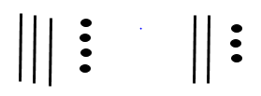  The units/ones are added first 4 + 3 = 7  The tens are added next  30 + 20 = 50  Both answers are put together 50 + 7 = 57  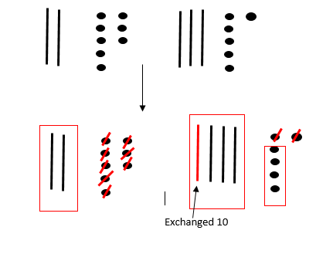  28 + 36 = ?  The units/ones are added first  8 + 6 = 14 with ten units/ones exchanged for 1 ten.  A ring is put around the units/ones not exchanged –  this is the units part of the answer. The tens are then  added, including the exchanged ten, to complete the  sum.
Progression Towards Written Calculation Strategies – Subtraction
Subtract a two digit number from a two digit number  Concrete – Diennes equipment, place value counters  Pictorial – tens and ones jottings | 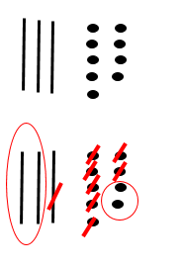  39 – 17 = ?  39 is drawn  17 is crossed out  A ring is drawn around what is left to give the answer of 22  37 – 19  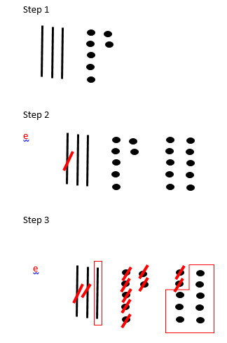  37 is drawn  9 units/ones cannot be crossed out, so one ten is crossed  out and exchanged for 10 ones which are in a line.  e is written next to the exchanged ten.  19 is crossed out  A ring is drawn around what is left to give  the answer of 18
Progression Towards Written Calculation Strategies – Multiplication
Recognise multiplication as real arrays and understand that multiplication is repeated addition and the total can be found by counting in equal steps/groups.  Concrete – real arrays e.g. baking trays, ice cube trays, egg boxes, cubes, counters  Pictorial – images of real arrays, rectangles drawn on squared paper | 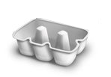  How many eggs are needed to fill the box?  How many eggs would fill two boxes?  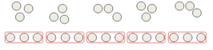  Children arrange items into equal groups  and count to find the total.  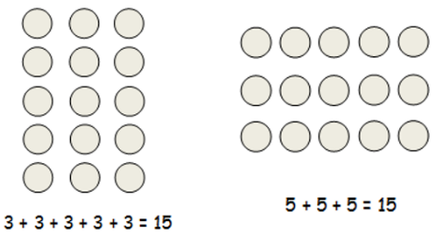  Children understand how arrays can show  repeated addition of rows and/or columns  and that multiplication is commutative i.e.  that 3 x 5 gives the same answer as 5 x 3
Progression Towards Written Calculation Strategies – Division
Represent division calculations as grouping (repeated subtraction) and sharing and use jottings to support their calculation. Introduce simple remainders as the items are shared into equal parts, but some may be left over.  Concrete – real sets of items, cubes, counters  Pictorial – images real items, rectangles drawn on squared paper | 12 ÷ 3 = ?  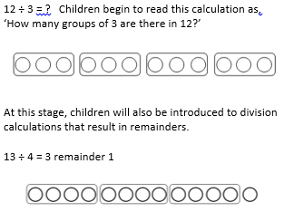  Children begin to read this calculation as,  ‘How many groups of 3 are there in 12?’  At this stage, children will also be introduced  to division calculations that result in remainders.  13 ÷ 4 = 3 remainder 1
Decision Making
When calculating, children should ask themselves:
- do I know the answer because it is a fact I have learnt?
- can I work it out easily in my head?
- can I use some equipment or a jotting?

The strategies used within this document are taken from the Lancashire Mathematics Team Progression in Mental Calculation Strategies Policies and the Progression Towards Written Methods Policies.
See www.lancsngfl.ac.uk/curriculum/primarymaths for the full policies.

