EYFS Computing LTP

Understanding the World (Technology) • Children recognise that a range of technology is used in places such as homes and schools. They select and use technology for particular purposes. • Understand that you may have to put your name/password into the device to retrieve your own files • Understand that you can connect with others via a device • Experience digital devices with an input/output. • Change the output of a device/toy by altering the input • Experience research via whole class activities • Know that information and a range of services can be found online • Use the keyboard to enter own name and print document • Use the keyboard and mouse to move a character around a game • Experience recording own voice and hearing the playback. • Experience videos of self and ability to re-watch

KS1 Computing LTP

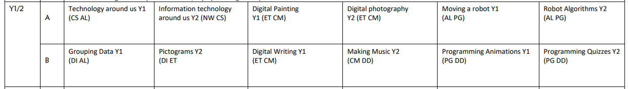

KS2 Computing LTP
 | 2023-2024 | 2024-2025 | 2025-2026
Year 3/4 | Cycle 1 | Cycle 2 | Cycle 1
Year 4/5 | Cycle 3 | Cycle 2 | Cycle 3
Year 6 or Y5/6 | Year 6 | Year 6 | Cycle 3



