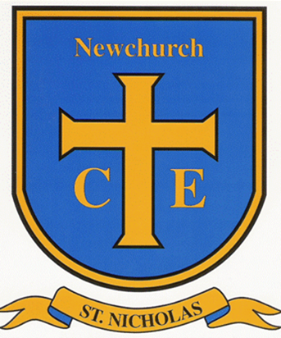

School acronyms can be rather confusing … but not with our handy guide!
Below are a number of terms which you may come across whilst your child is in education.

TA - Teaching Assistant

SEND – Special Educational Needs and Disabilities

SEND Register - List of children who have Special Educational Needs and Disabilities (diagnosed or undiagnosed).

SENDCo/SENCo - Special Educational Needs and Disability Co-ordinator- that’s me, Mrs. Phelan.

LDD– Learning Difficulties and/or Disability

IEP - An Individual Educational Plan: An Individual Education Plan or IEP is a school-based document which records, tracks and reviews the support a child with special educational needs receives in school. An IEP is normally reviewed at the end of each school term.

IBP – Individual Behaviour Plan: An Individual Behaviour Plan or IBP is a school-based document which is prepared to help support a pupil with behaviour difficulties. Behaviour difficulties can be a sign of special educational needs. If the IBP is inadequate and external help is needed, it may be necessary to seek an EHC needs assessment.

EHCP – Education, Health Care Plan: An Education, Health and Care Plan or EHCP is a legally binding document which sets out a child or young person’s special educational needs and disabilities and the support they require.

AR- Annual Review: An Annual Review or AR is a meeting to consider the support a child or young person receives through their Statement of Special Educational Needs or Education, Health and Care Plan. The review should take place once a year, although reviews can be called early if significant changes occur. The review should consider whether the provision, placement and objectives (or outcomes) are still appropriate.

EP – Educational Psychologist: An educational psychologist or EP is a medical professional trained to assess and diagnose learning difficulties, social and emotional problems and developmental disorders. They are typically central to assessing special educational needs, recommending support and differentiation of the curriculum.

SALT or SLT – Speech and Language Therapist: Speech and Language Therapists, SALT or SLT assess and treat speech, language and communication problems in people of all ages to help them better communicate. They also work with people who have eating and swallowing problems. SLTs can be important in assessing children and young people with special educational needs and providing them with additional support.

CAHMS – Child Adolescent Mental Health Service: The Child and Adolescent Mental Health Service or CAMHS is a specialist part of the NHS which provides assessment and treatment when children and young people have emotional, behavioural or mental health difficulties. GPs often refer children to CAMHS for assessment of special educational needs and disabilities. CAMHS can often be important in securing support for special educational needs and disabilities.

OT- Occupational Therapist: An occupational therapist or OT is a medical professional who practices occupational therapy. Occupational therapy is the assessment and treatment of physical and psychiatric conditions using activities to limit the impact of the disability and promote independence. OTs can be important in assessing and supporting children and young people with special educational needs.

PIVATS/P scales- Performance Indicators for Value Added Target Setting, PIVATS or P scales: achievement levels used to monitor the ability and progress of children who are not yet performing at National Curriculum level. The longer a child or young person is at this level, the more likely it is they have special educational needs.

CFWS – Child and Family Wellbeing Service: The Children and Family Wellbeing Service, previously children's centres and Young People's Service, provide services to help with parenting and other support you may need. Find your nearest service here: https://fisonline.lancashire.gov.uk/SynergyWeb/Enquiries/Search.aspx?searchID=231

EHA – Early Help Assessment: The Early Help Assessment, referred to as 'Your Family's' Early Help Assessment' is a tool used to support work with families. It is designed to help professionals work with families to identify their needs and plan appropriate responses.

TAF Plan – Team Around the Family Plan: Team Around the Family meetings are where the family and practitioners come together to review the family’s plan. TAF meetings allow a family and practitioners to share and celebrate success, review the desired changes and agree next steps. With the consent of the family, TAF meetings can continue to take place every four to 12 weeks for as long as the family feel they are needed.

If you ever need any help with our acronyms, please ask any member of staff for support as we are here to help our families and community as much as we can.

