Dear Parent/Carer,

We are hoping to see you all soon, however as it is still uncertain when all children will be able to return to school, we are going to be trialling a new system from Friday 26th June to make home learning easier and more accessible for all.

Microsoft Teams is an online classroom where teachers will be able to communicate with pupils, teach online and set work for them. You will also be able to complete work on here with the certainty that only you and the teachers allocated to your class can see it. The idea is that your child will be able to log on to their own user space and access work your teacher has set for them. If you do not have access to any of the windows programs, you will be able to use them for free through this application to complete work. Alternatively, you can take pictures using your smart device and upload them.

Here attached are some basic instructions to get you started. There is also a link provided to an instructional video with more information should you require it.

To log on, type www.office.com in your browser and click sign in. You will then need to enter the username and password you have been given by school via Parent Mail. It will prompt you to create a new password, this should be one you will be able to remember but not easy for others to guess. It will need to contain at least one capital letter and should not contain inappropriate language. Please note that if at some point you forget your password, please inform school and we can reset it for you. Once you have logged in, you should then see the following screen:

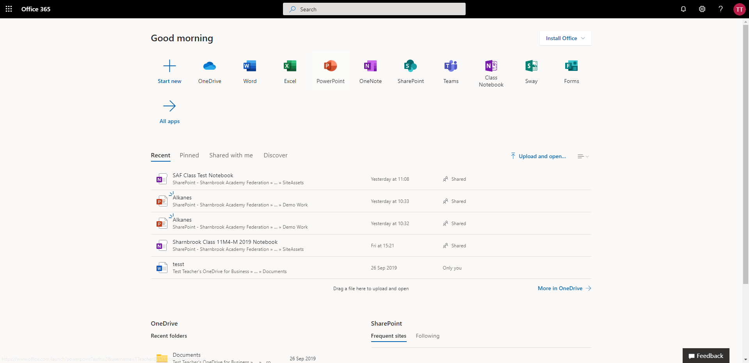

Click on the Teams app to open, circled in red. When you launch the Teams app, you will arrive at your Teams dashboard. The centre of your screen will contain white tiles with the Teams you are in, for example:
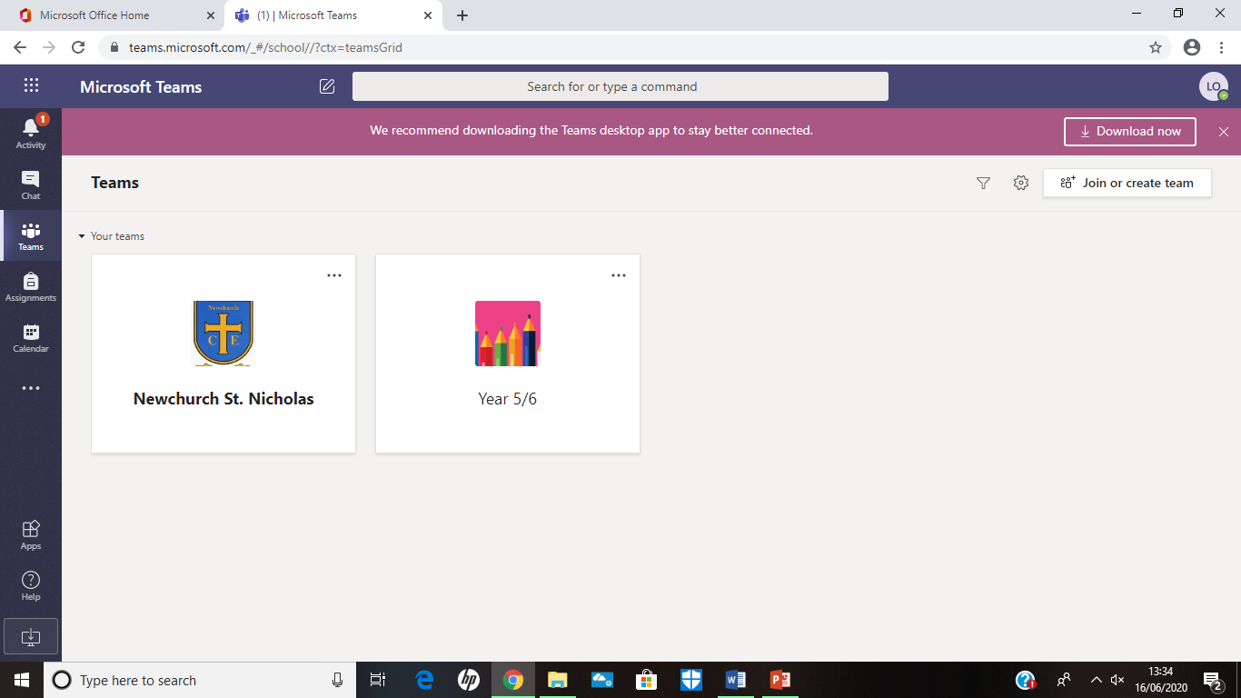

In this example, this person is in 2 Teams. You can be part of just one or multiple teams, organised by subject and class. These have already been set up for you.

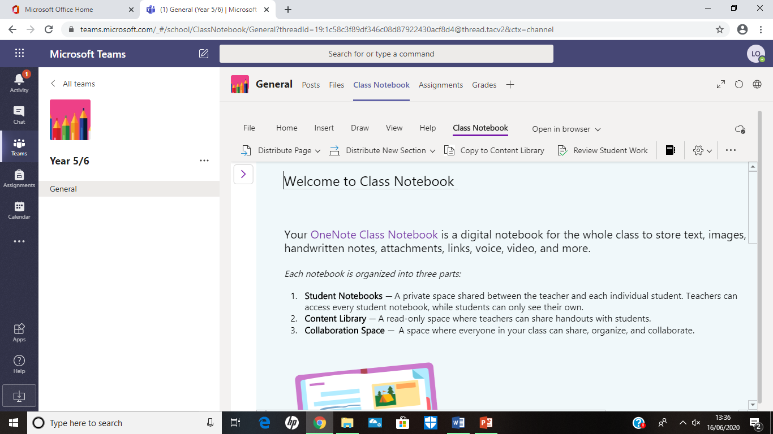

By clicking on Class Notebook, circled in red, you can access items your teacher has set for you. This may be a piece of text, images, video clips or power points.

To access and complete work set, click on the files tab.

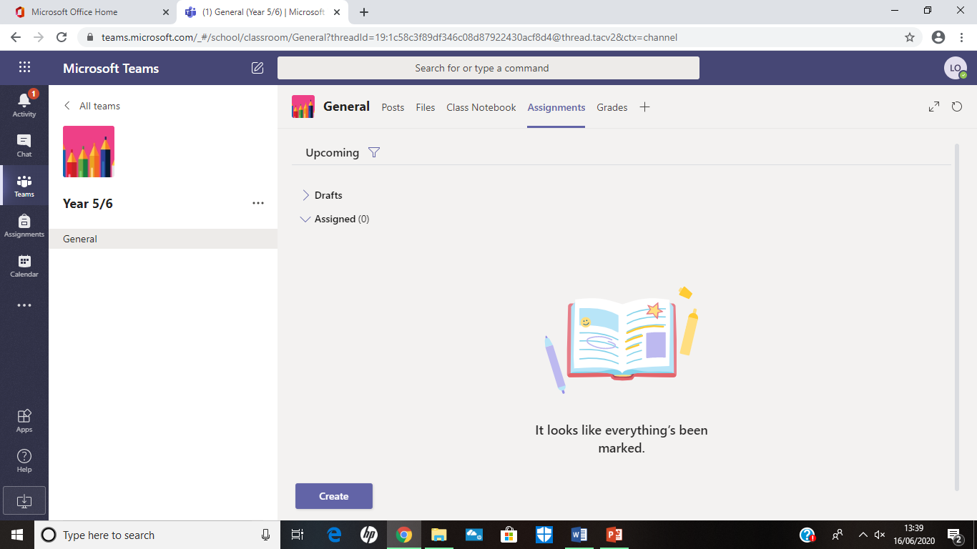

Even if you do not have access to Microsoft Word or Power Point at home, this application will allow you to access it for FREE and your teacher will be able to see what you have completed without needing to email it to them.

Your teacher may want to make a conference call during lesson time if you are unable to come to school so that you do not miss out on instructions your classmates will be getting in class. Video instructions for this and the information already discussed can be accessed by following this link https://www.youtube.com/watch?v=SemjM2fHV2Q&safe=active This may not be something all teachers do to begin with, as we will trial the streaming with some classes first to iron out any teething problems that may occur, however you will be informed as to when your teacher will be doing this.

Finally, please be aware that as of next week, all staff will be teaching in some capacity, whether this be with a year group that has returned, or with a Key Worker bubble. Consequently, when your child submits their work, they may not receive a reply immediately and it may not necessarily be your class teacher who replies each time. Please be assured your child will receive feedback for their work as soon as possible as we feel it is important to praise your child for their hard work. Teachers will not be obligated to reply during weekends or evenings unless at their own discretion, although you may still submit work the if you wish and feedback will be given during a working day.

I hope this will be a fantastic and exciting tool to help your children with their learning, and it will be of great benefit for them in the future as more high schools are using similar programs to submit assignments electronically. It will also be of value when school returns to a more normal routine and we have lots of ideas of how to use it to enrich your children’s learning.

Thank you and stay safe,

L. O’Mara

