Dear Parents and Carers,
As we approach the SATs assessments in May, I am writing to inform you that we will be introducing weekly literacy and numeracy homework. This will begin immediately.
Historically, we have found that a “little and often” approach is far more effective in preparing children for SATs than last-minute revision. It is also significantly less stressful for pupils. Feedback from past pupils has been overwhelmingly positive, with many reporting that they enjoyed the weekly homework, felt well prepared for the tests, and found it helped keep their knowledge fresh throughout the year.
An additional benefit of this approach is that it allows you, as parents and carers, to see exactly what your child has been learning in class.

Homework structure and expectations
Each week, children will receive:
- One literacy (English) homework
- One numeracy (Maths) homework
Both pieces of homework will be based on learning that has already taken place in class that week, or will be a consolidation task on an area your child is very familiar with. This means all children should be able to access the work — even if they initially feel unsure and say they “haven’t learned it”!

We are encouraging children to gradually increase the amount of time they spend reading at home, aiming to build up to 30 minutes of sustained reading in one sitting. This will help strengthen their reading stamina in preparation for the reading test and for the demands of high school. To support this further, we will also be introducing a weekly extended silent reading session in school. Please note that for reward time, we will still only require one recorded home read per week, regardless of how long your child reads for.

Homework will:
- Be set weekly
- Be due in promptly every Friday
- Be reviewed together as a class as part of our revision work
Submitting homework on time is essential. If work is late, pupils miss out on the valuable class discussion and feedback. Timely submission also allows me, as the class teacher, to identify any areas where pupils may need further support.
Rewards and preparation for secondary school
Both pieces of homework must be handed in on Friday to count towards your child’s end-of-term reward time. This routine also helps children develop good study habits, organisation, and responsibility, which are vital skills as they prepare for secondary school.

How you can support at home
You can help your child by:
- Encouraging them to complete homework on the same day each week
- Providing a quiet space with minimal distractions
- Supporting them if needed — homework is not designed to be a test but a learning and revision opportunity
- We strongly encourage pupils to look at their homework early in the week. If they find it challenging, they should speak to me in plenty of time so support can be given. There is also a Wednesday lunchtime homework club available for pupils who would benefit from extra help.
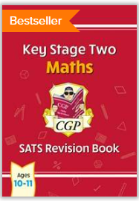
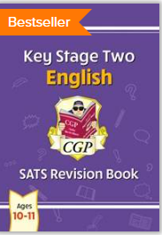

Resources provided
Your child will receive:
- Two coloured study guides (one English, one Maths)
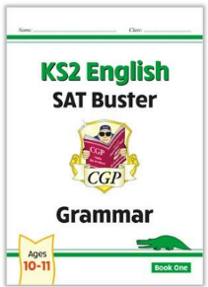
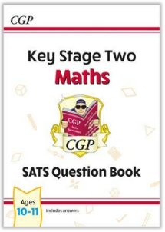
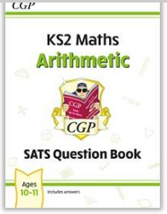
- These contain helpful reading material, explanations, and examples
  - They will need to be returned after SATs
- Three white workbooks (Grammar, Arithmetic, and Maths Questions)
  - These are used to complete homework
  - Pupils may keep these after SATs if they wish
Please encourage your child to bring all books back every Friday, as we use Friday afternoon to go through the following week’s homework together before home time.
Occasionally, homework may be set on a separate worksheet rather than in one of the workbooks. This will be because it links particularly well to what we have been learning in class or is more appropriate for your child’s individual level, whether that is providing additional support or offering further challenge.

Communication
Homework details will:
- Be sent home each week on paper slips
- Be posted online on our class webpage
Thank you very much for your continued cooperation and support. Working together in this way will help ensure your child feels confident, prepared, and calm as we move towards SATs.

If you have any questions, please do not hesitate to get in touch.
Kind regards,

Mrs L. O’Mara

