Set: 13.03.2026
Due: 20.03.2026

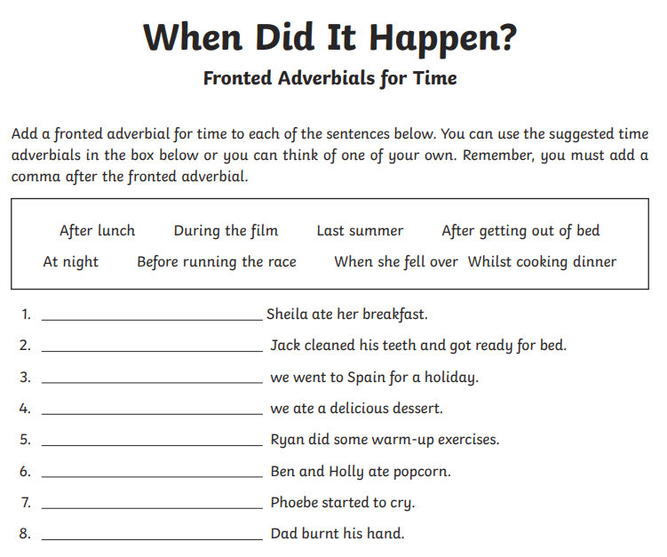
English

Maths: Division as repeated subtraction on a numberline



