Autumn 2
Y6 Take Away Homework

Choose your homework from the menu below:
The Peri-ometer suggests the difficulty or challenge the
homework may offer. Each week you must choose your task from the menu. You may choose to complete more than one if you wish. Homework should be returned on a Wednesday morning.
These homework tasks are in addition to TTRS and home reading tasks.
Each of the homework tasks are worth the following rocket points:
Extra Hot 15 Mild 5
Hot 10 Extra Mild 2

Creativity/Geography  Make a model of the Alps! You can do this using any media you like such as papier-mâché, clay or recycled materials.  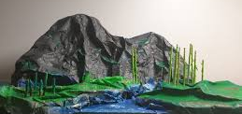 | Geography  Create a double page spread about the Alps. You should include pictures/photos as well as lots of information. You can type or write this, but you must not copy word-for-word or copy and paste. You may include information such as:  - Where the Alps are  - A map  - Who lives there  - What it is like to live there  - Animal and plant life | PE/ Physical Activity  Create or design an obstacle course. Suggestions for how you can show this are:  *Make an obstacle course at home, take photos, stick them in your homework book and bring this in.  * Make an obstacle course at home, ask someone to film you completing it, and email this to school.  * Draw, colour and label your obstacle course in your book.
Art/Christian Values  Our key Christian value for this half term is TRUST. Make a collage of someone you trust and write a sentence or two saying why you feel you can trust them. | 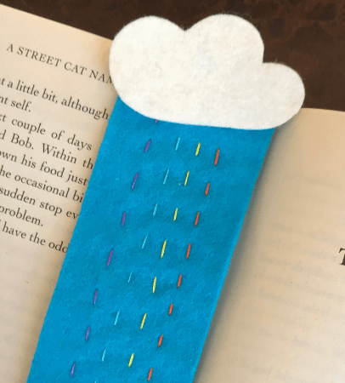  DT/ Textiles.  In DT this half term we will be making waistcoats using running stitch. Could you make a small textile item such as a bookmark using the running stitch? | Music  Research a composer you like the music of. Create a fact file about them. You can choose one of your own and create it or you can do one about Mozart and collect a sheet from class/class webpage to write on. You could do a modern-day composer such as Lin-Manuel Miranda or Elton John or Danny Elfman!
Science  Complete the circuit homework by labelling the diagram. Find this on our homework board in class on or our class page on the school website. | Oracy/ Poetry  Find a poem you really enjoy. Learn it by heart (without needing to read the words). Perform this in front of the class. | Celebrations!  We are coming to the time of year where there are celebrations in lots of different cultures e.g. Diwali and Christmas. Create some artwork to show one of these celebrations.
Reading  Ask your teacher for a 60 second task comprehension sheet to complete. | French  Practice your French colours by completing the sheet (on our homework board in class) and reading the French words aloud. | TTRS  Go on to TTRS at home for 15 minutes. I will be checking online!

